|  |  |
| --- | --- |
| M.MERT TURMUŞ | P1090261.JPG |

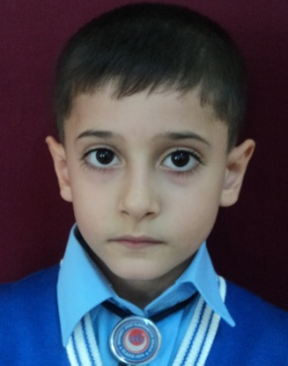

|  |  |
| --- | --- |
| m.murat ozan |  |

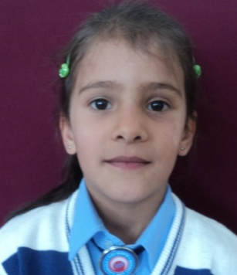

|  |  |
| --- | --- |
| Sakine kayaokay |  |

|  |  |
| --- | --- |
| GÜLİZAR OĞUL |  |

|  |  |
| --- | --- |
| NİDA CANBAY | P1090261.JPG |

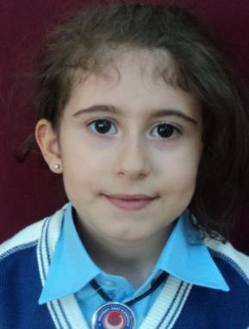

|  |  |
| --- | --- |
| SÜMEYRA PEKMEZ |  |

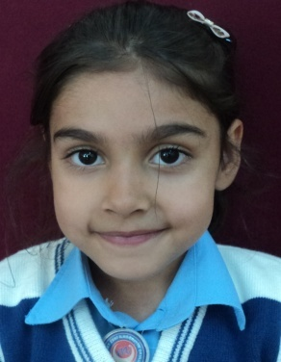

|  |  |
| --- | --- |
| ELA İRHAN |  |

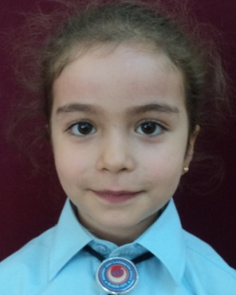

|  |  |
| --- | --- |
| ZEYNEP KOÇAK |  |

|  |  |
| --- | --- |
| MUHAMMED HAYTA | P1090261.JPG |

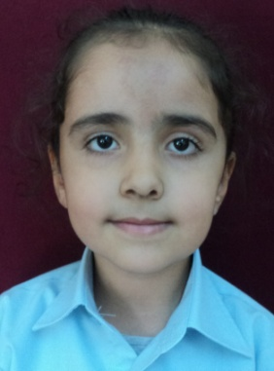

|  |  |
| --- | --- |
| IRMAK KANDEMİR |  |

|  |  |
| --- | --- |
| KAAN YENİGÜN | P1090261.JPG |

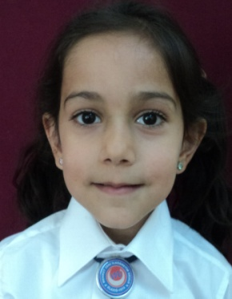

|  |  |
| --- | --- |
| SUDENAZ AKTAŞ |  |

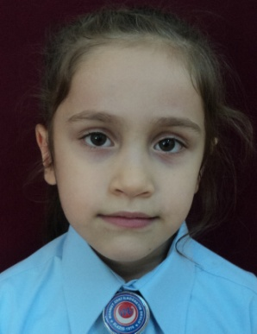

|  |  |
| --- | --- |
| NERMİN ALANBAY |  |

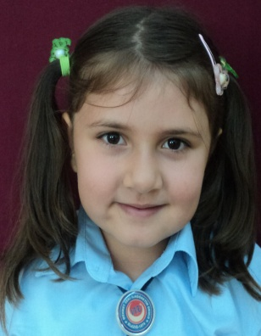

|  |  |
| --- | --- |
| BUSENUR ÇAKAR |  |

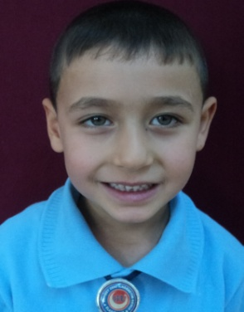

|  |  |
| --- | --- |
| KENAN ÜZER |  |

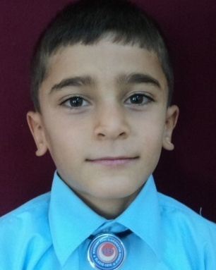

|  |  |
| --- | --- |
| MİRAÇ ÇAY |  |
| ELİF ÖZDEMİR |  |

|  |  |
| --- | --- |
| GÜLİZAR OĞUL |  |

|  |  |
| --- | --- |
| Habip ardiç |  |